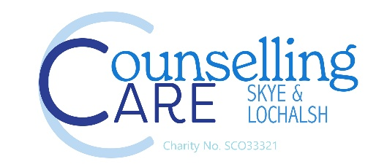

Job Description

Job Title: Children and Young People Lead Counsellor
Location: Portree and Plockton High schools and feeder primary schools
Hours: 24.5 hours or 3.5 days per week
Salary £27,260 per annum / £23.18 per hour
We are seeking an experienced and compassionate person to lead and support the delivery of high-quality counselling services for children and young people aged 5–18 years in Skye and Lochalsh.

The successful candidate will manage a caseload, oversee staff workloads, coordinate referrals, maintain reporting systems, and work collaboratively with schools and external agencies to ensure effective support for young people and families.

Training and qualifications
Accredited Diploma in Counselling and membership of BACP or COSCA. Specialist Diploma or postgraduate qualification in counselling children and young people. Evidence of commitment to Continuing Professional Development.

Key Responsibilities

Provide therapeutic counselling support to children and young people aged 5–18.
Delegate workload between yourself and one member of staff.
Assess client needs and deliver counselling sessions.
Maintain accurate, confidential, and up-to-date case records.
Safeguard children and young people in line with organisational and statutory safeguarding procedures.
Support children presenting with emotional, behavioural, social, and mental health difficulties.
Organise resources for play therapy including craft boxes and games.

Leadership and Staff Management

Organise and oversee team workloads effectively.
Manage staff allocation and delegate client referrals appropriately across the counselling team.
Provide guidance, supervision support, and leadership to counselling staff.
Support the development of a positive, professional, and collaborative team culture.

Partnership Working

Build and maintain positive working relationships with schools, educational professionals, and external agencies.
Demonstrate a strong understanding of the education system and the challenges affecting children and young people in the area.
Attend meetings with schools, professionals, and other agencies when required.

Reporting and Administration

Collate service statistics, outcomes, and performance data accurately.
Produce reports for Scottish Government and CCSL
Monitor service delivery through CORE analysis.
Ensure compliance with GDPR, safeguarding, and organisational policies.
Contribute to funding bids

Strategic and Board Participation

Attend and contribute to board meetings and strategic service discussions.
Contribute ideas and recommendations based on service data and frontline experience.

Person Specification
Essential Requirements

Relevant counselling qualification and professional membership/accreditation.
Experience working therapeutically with children and young people aged 5–18.
Strong organisational and workload management skills.
Experience collating statistics, data analysis, and report writing.
Excellent communication and relationship-building skills.
Good understanding of safeguarding legislation and procedures.
Strong understanding of the education system and partnership working within schools.
Full UK driving licence and access to a vehicle.

Desirable Skills and Experience

Knowledge of trauma-informed practice and neurodiversity.
Experience using case management or reporting systems.
Leadership skills

Personal Qualities

Compassionate and child-centred approach.
Strong leadership and decision-making abilities.
Professional, reliable, and adaptable.
Ability to work independently and as part of a multidisciplinary team.

